NFC-IET UNIVERSITY, MULTAN



LAB REPORT

ICT (“Information & Communication Technology Fundamental”)

## For the degree of Bacheller of Science

In Computer Science

Session [2k24]

**Name: Laiba**

**Roll NO : (2k24-BSCS-432)**

**Section : Y**

### Submitted To: **Miss Fabia Hassan**

### Submitted By: **Laiba**

## October 2024

**LAB 1**

Typing Practices (Typing tutor)

* ***Main components***

1. **CPU (CENTRAL PROCESSING SYSTEM ):**

* RECOGNITION: A small, square or rectangular chip, usually with a heat sink and fan attached.
* UNDERSTANDING: Executes instructions, performs calculations, and controls data transfer between components.

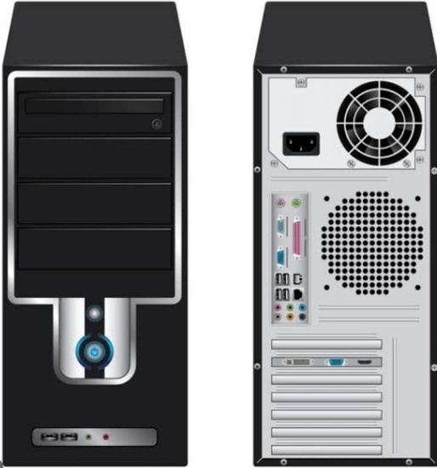

1. **MOTHERBOARD:**

* RECOGNITION: A large flat circuit board with various sockets, slots and connectors.
* UNDERSTANDING: Connects all hardware components, provides pathway for data transfer, and regulates power supply.

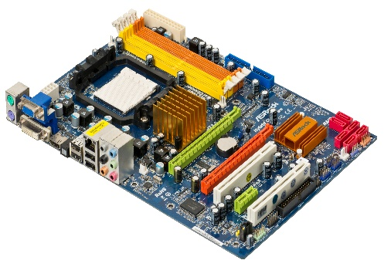

1. **MEMORY (RAM):**

* RECOGNITION: Long, thin modules with chips and pins, usually installed in slots on the motherboards.
* UNDERSTANDING: Temporarily storage for data, applications, and operating system, enabling fast access and processing.

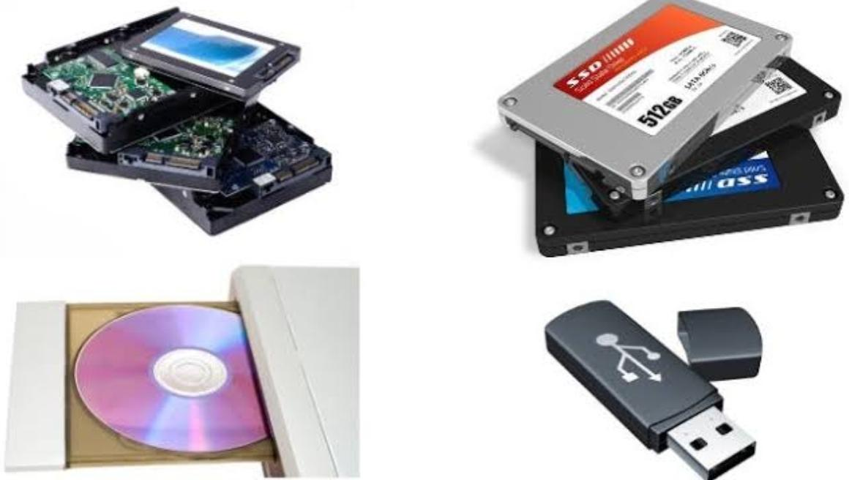

1. **STORAGE DRIVE:**

* RECOGNITION: A flat, rectangular device with connectors and cables, usually installed in a drive bay.
* UNDERSTANDING: Permanent storage for data, programs, and operating system, providing long term retention and retrieval.

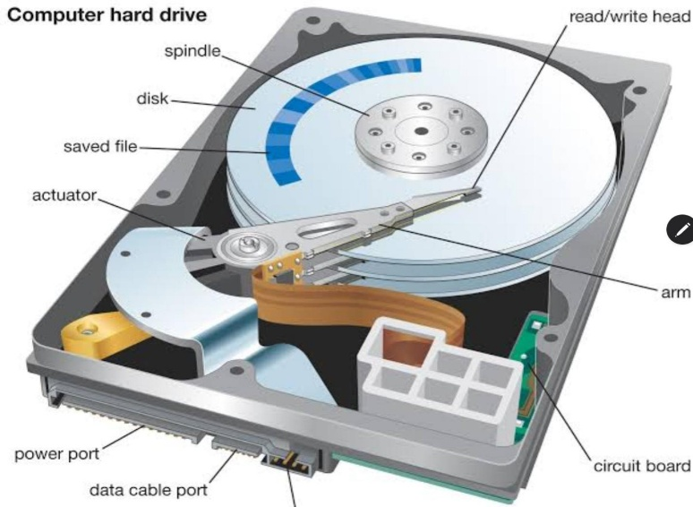

* ***Additional Components:***

1. **GRAPHICS CARD:**

* RECOGNITION : A separate card with a GPU(Graphics professing unit), usually installed in a PCL slot.
* UNDERSTANDING: Controls output display , handles graphics processing, and provides improved gaming and graphics performance.

1. **POWER SUPPLY:**

* RECOGNITION: A rectangular device with cables and connectors, usually installed in a power supply bay.
* UNDERSTANDING: Converts AC power from the mains to DC power for components, regulating voltage and current.

1. **COOLING SYSTEM:**

## RECOGNITION: Fans, heat sink, and liquid cooling systems, usually installed on the CPU, GPU , or case.

* UNDERSTANDING: Regulates temperature, prevents overheating, and maintains optimal performance.
* ***Other Components:***

1. **CASE:**

* RECOGNITION: The outer casing of the computer, usually made of metal, plastic, or a combination.
* UNDERSTANDING: Holds all internal components together, provides protection, and facilitates airflow and cooling.

1. **THERMAL PASTE :**

* RECOGNITION**:** A small, grey, or white paste, usually applied between the CPU and heat sink.
* UNDERSTANDING: Transfers heat from the CPU to the heat sink, improving cooling efficiency.

1. **BATTERIES :**

* RECOGNITION: Small , round batteries, usually installed on the motherboard.
* UNDERSTANDING: Powers the CMOS ( Complementary Metal-Oxides-Semiconductor) chip, clock and other Components when the system is off.

## **LAB 2:** **WINDOWS INSTALLATION:**

* ***PRE-INSTALLATION STEPS****:*

1. **BACKUP DATA:** Save important files and data to an external drive or cloud storage.
2. **CHECK SYSTEM REQUIREMENTS:** Ensure your computer meets the minimum system requirements for the Windows version you’re install
3. **CREATE A BOOTABLE MEDIA:** Use a USB drive or DVD to create a bootable installation media.
4. **DISABLE SECURE BOOT:** If your computer has Secure Boot Enabled, disable it to allow the installation to proceed.

* ***INSTALLATION STEPS:***

1. **INSERT THE INSTALLATION MEDIA:** Plug in the USB drive or insert the DVD.

1. **RESTART YOUR COMPONENTS:** Reboot your computer and enter the BIOS settings (usually by pressing F2, F12, or Del).
2. **SET THE BOOT ORDER:** Set the USB drive or DVD as the first boot device.
3. **SAVE THE EXIT:** Save the changes and exit the BIOS settings.
4. **WINDOWS SETUP:** The Windows installation step will begin. Follow the prompts to:

* Select your language and keyboard layout.
* Accept the licence terms.
* Choose the installation type (Custom or Upgrade).
* Select the disk where you want to install windows.

1. **INSTALL WINDOWS:**The installation process will begin. This may take several minutes to an hour, depending on your computer’s hardware.
2. **ACTIVATE WINDOWS:** Once the installation is complete, you will need to activate windows using a valid product key.
3. **SET UP YOUR ACCOUNT:** Create a user account and set up your windows settings.

* ***POST-INSTALLATION STEPS:***
* UPDATE WINDOWS
* INSTALL DRIVESRS
* INSTALL ANTIVIRUS SOFTWARE
* TRANSFER FILES

**CPU ASSEMBLING:**

**CPU assembling has the following steps:**

* **Step 1:** Locate the CPU socket
* **Step 2:** Apply thermal paste (if necessary)
* **Step 3:** Install the CPU
* **Step 4:** Install the CPU cooler (if applicable)
* **Step 5:** Connects the CPU power cable
* **Step 6:** Connect the CPU fan cable ( if applicable)
* **Step 7:** Final check

**LAB 3: MOTHERBOARD AND ITS INTERNAL STRUCTURE**

* ***MOTHERBOARD*:**

A motherboard is the main circuit board of a computer, connecting all hardware components together. It's essentially the backbone of the computer, allowing all the components to communicate with each other.

* ***Main Components*:**

**1. CHIPSET:** A group of chips that manage data transfer between components.

**2. CPU SOCKET** The socket that holds the CPU in place.

**3. MEMORY SLOTS (RAM)**: Slots for installing RAM modules.

**4. EXPANSION SLOTS** : Slots for adding expansion cards (e.g., graphics cards, sound cards).

**5. STORAGECONNECTORS**: Connectors for hard drives, solid-state drives, and other storage devices.

* ***Internal Structure:***

**1. Copper Layer:** The outermost layer, made of copper, which provides electrical connections between components.

**2. INSULATION LAYER:** A thin layer of insulation material (e.g., fiberglass, ceramic) that separates the copper layer from the next layer.

**3. SIGNAL LAYER:** A layer of copper wiring that carries signals between components.

**4. POWER LAYER:** A layer of copper wiring that carries power to components.

**5. GROUND LAYER:** A layer of copper wiring that provides a ground connection for components.

* ***Buses and Interfaces:***

**1. FRONT-SIDE BUS (FSB):** A bus that connects the CPU to the chipset.

**2. BACK-SIDE BUS (BSB):** A bus that connects the CPU to the Level 2 (L2) cache.

**3. PERIPHERAL COMPONENT INTERCONNECT (PCI):** A bus that connects peripherals (e.g., graphics cards, sound cards) to the chipset.

**4. PCI EXPRESS (PCI):** A high-speed bus that connects peripherals (e.g., graphics cards, sound cards) to the chipset.

* ***Power Delivery:***

**1. POWER PHASES:** A system that delivers power to the CPU and other components.

**2. VOLTAGE REGULATOR MODULES (VRMs):** Modules that regulate the voltage supplied to thePU and other components.

**3. POWER CONNECTORS:** Connectors that supply power to the motherboard from the power supply unit (PSU).

## **LAB 4:** **Introduction to MS office :**

* **Microsoft world:**

Microsoft Word is a popular word processing software developed by Microsoft. It has advance features which allow users to create, edit, and print documents. It is also used to make professional-quality documents, letters, reports Etc.



* **Key Features of Microsoft Word*:***

**1. TEXT EDITING:** Word provides a wide range of text editing tools, including font styles, sizes, and colours.

**2. DOCUMENT FORMATTING:**Users can format documents using various layout options, including margins, indentation, and spacing.

***3.* GRAPHICSAND IMAGES:**Word allows users to insert graphics, images, and other multimedia elements into documents.

**4*.* TABLES AND CHARTS:**Users can create tables, charts, and other data visualization tools to present information.

***5.* COLLABORATION TOOLS*:*** Word provides features for real-time collaboration, including commenting, tracking changes, and co-authoring.

* **Basic Components of the Microsoft Word Interface:**

**1. MENU BAR:** The topmost bar that provides access to various menus, including File, Home, Insert, and more.

**2. TOOLBAR:** A row of icons below the menu bar that provides quick access to frequently used commands.

**3. DOCUMENT AREA:** The main area where users can create and edit documents.

**4. RIBBON:** A tabbed interface that provides access to various tools and features, including formatting, layout, and more.

***MS Word basic features:***

**There are the basic features of MS Word, organized by tab:**

* ***HOME TAB:***

1. **FONT:** Change font styles, sizes, and colours.

**2. PARAGRAPH:** Align text left, right, centre, or justify.

**3. STYLES: Apply** pre-defined styles to text and paragraphs.

**4. EDITING:** Use tools like cut, copy, paste, and undo.

* ***INSERT TAB:***

**1. PAGES:** Insert page breaks, cover pages, and blank pages.

**2. TABLES:** Create tables with various layouts and designs.

**3. ILLUSTRATIONS:** Insert images, shapes, and SmartArt graphics.

**4. LINKS:** Insert hyperlinks to web pages, email addresses, or files.

**5. HEADER & FOOTER :** Add headers and footers to documents.

* ***Layout Tab:***

**1.ORIENTATION:** Change the document orientation to portrait or landscape.

**2. SIZE:** Select from various paper sizes, including letter, A4, and more.

**3. MARGINS:** Set margins for the document, including top, bottom, left, and right margins.

* ***References Tab:***

**1. TABLE OF CONTENTS:** Create a table of contents for long documents.

**2. FOOTNOTES:** Insert footnotes to provide additional information.

**3. ENDNOTES:** Insert endnotes to provide additional information.

**4. CITATIONS & BIBLIOGRAPHY:** Manage citations and bibliographies for academic papers.

* ***Mailings Tab:***

**1. CREATE:** Create envelopes, labels, and mail merge documents.

**2. START MAIL MERGE:** Start a mail merge process to create personalized documents.

* ***Review Tab:***

**1. SPELLING & GRAMMARLY:** Check spelling and grammar errors in the document.

**2. THESAURUS:** Use the thesaurus to find synonyms for words.

**3. TRANSLATE:** Translate text from one language to another.

**4. COMMENTS:** Add comments to documents and respond to others' comments.

* ***View Tab:***

**1. DOCUMENT VIEWS:** Switch between different document views, such as print layout, web layout, and outline view.

**2. ZOOM:** Zoom in or out of the document.

**3. SHOW:** Show or hide various document elements, such as gridlines, rulers, and headers.

## **LAB 5: MS word Advanced features including :**

* ***MAIL MERGE:***

**1. CREATE A DATA SOURCE :** Create a data source, such as an Excel spreadsheet or a Word table, that contains the data you want to merge.

**2. CREATE A MAIL MERGE DOCUMENT:** Create a new Word document and go to the "Mailings" tab. Click on "Start Mail Merge" and select "Step-by-Step Mail Merge".

**3. CONNECT TO THE DATA SOURCE:** Connect to the data source by clicking on "Select Recipients" and selecting the data source.

**4. INSERT MERGE FIELDS:** Insert merge fields into the document by clicking on "Insert Merge Field" and selecting the field you want to insert.

**5. PREVIEW AND COMPLETE THE MERGE:** Preview the merge by clicking on "Preview Results" and then complete the merge by clicking on "Finish & Merge".

* ***TABLE OF CONTENTS:***

**1. CREATE A TABLE OF CONTENTS**Create a table of contents by going to the "References" tab and clicking on "Table of Contents".

**2. SELECT THE TABLE CONTENT STYLES:** Select the table of contents style you want to use.

**3. CUSTOMIZE THE TABLE CONTENTS:** Customize the table of contents by clicking on "Customize" and selecting the options you want.

**4. UPDATE THE TABLE OF CONTENTS :** Update the table of contents by clicking on "Update Table".

* ***SECTION BREAKS:***

**1. INSERT A SECTION BREAK:** Insert a section break by going to the "Layout" tab and clicking on "Breaks".

**2. SELECT THE SECTION BREAK TYPE :** Select the section break type you want to use (e.g. "Next Page", "Continuous", etc.).

**3. CUSTOMIZE THE SECTION REAK:** Customize the section break by clicking on "Section" and selecting the options you want.

* ***REFERENCES:***

**1. INSERT A CITATION:** Insert a citation by going to the "References" tab and clicking on "Insert Citation".

**2. SELECT THE CITATION STYLE:** Select the citation style you want to use (e.g. "APA", "MLA", etc.).

**3. CUSTOMIZE THE CITATION:** AAtomise the citation by clicking on "Citation Options" and selecting the options you want.

**4. INSERT A BIBLIOGRAPHY:** Insert a bibliography by going to the "References" tab and clicking on "Bibliography".

* ***HEADERS AND FOOTERS :***

**1. INSERT A HEADER OR FOOTER:** Insert a header or footer by going to the "Insert" tab and clicking on "Header" or "Footer".

**2. SELECT THE HEADER OR FOOTER STYLE:** Select the header or footer style you want to use.

**3. CUSTOMIZE THE HEADER OR FOOTER:** Customize the header or footer by clicking on "Header & Footer Tools" and selecting the options you want.

**4. LINK TO PREVIOUS:** Link to previous headers or footers by clicking on "Link to Previous".

* ***Tips for using headers and footers efficiently:***
* Use the **"Link to Previous"** feature to link headers and footers across multiple pages.
* Use the **"Different First Page"** feature to create a different header or footer for the first page of a document.
* Use the **"Different Odd & Even Pages"** feature to create different headers or footers for odd and even pages.

**LAB 6:** Using Mendeleyev, Grammar & PDF Element, Automation with Macros Create and run macros for repetitive tasks, PDF to word conversion, Referencing Tools & Citations, referencing tools for citations, footnotes, and endnotes.

* ***GRAMMARLY AND MENDELEYEV INTEGRATION :***

**1. INSTALL GRAMMARLY:** Download and install the Grammarly add-in for Microsoft Word.

**2. INSTALL MANDILEVE:** Download and install the Mendeleev add-in for Microsoft Word.

**3. INTEGRATE GRAMMARLY AND MANDILEVE:** Follow the instructions to integrate Grammarly and Mendeleev.

* ***CREATING MACROS FOR REPETITIVE TASKS:***

**1. OPEN MICROSOFT WORD:** Open a new or existing document in Microsoft Word.

**2. ACCESS THE DEVELOPER TAB :** Click on the "Developer" tab in the ribbon.

**3. CLICK ON MACROS:** Click on the "Macros" button in the "Developer" tab.

**4. CREATE A New MACROS:** Click on "Create" to create a new macro.

**5. RECORD THE MACRO:** Click on "Record" to start recording the macro.

**6. PERFORM THE REPETITIVE TASK:** Perform the repetitive task you want to automate.

**7. STOP RECORDING:** Click on "Stop Recording" to stop recording the macro.

**8. SAVE THE MACRO:** Save the macro with a descriptive name.

* ***PDF to Word Conversion using PDF Element:***

**1. OPEN PDF ELEMENT:** Open PDF Element on your computer.

**2. SELECT THE PDF FILE:** Select the PDF file you want to convert to Word.

**3. CLICK ON CONVERT:** Click on the "Convert" button to start the conversion process.

**4. SELECT THE OUTPUT FORMAT :** Select "Word" as the output format.

**5. CONVERT THE PDF:** Click on "Convert" to convert the PDF to Word.

* ***Referencing Tools and Citation Referencing Tools:***

**1. USE THE REFERENCES TAB:** Use the "References" tab in Microsoft Word to access referencing tools.

**2. INSERT A CITATION:** Click on "Insert Citation" to insert a citation.

**3. SELECT THE CITATION STYLE :** Select the citation style you want to use (e.g. APA, MLA, etc.).

**4. INSERT A BIBLIOGRAPHY:** Click on "Bibliography" to insert a bibliography.

* ***Creating and Running Macros for Citation and Footnotes:***

**1. CREATE A NEW MACRO:** Create a new macro using the steps above.

**2. RECORD THE MACRO:** Record the macro by performing the steps to insert a citation or footnote.

**3. STOP RECORDING :** Stop recording the macro.

**4. SAVE THE MACRO:** Save the macro with a descriptive name.

**5. RUN THE MACRO :** Run the macro by clicking on the "Macros" button and selecting the macro.

* ***Automation with Macros:***

**1. AUTOMATE REPETITIVE TASKS:** Automate repetitive tasks by creating and running macros.

**2. USE MACROS TO FORMAT DOCUMENTS:** Use macros to format documents, including inserting headers and footers, and formatting text.

**3. USE MACROS TO CONVERT PDFs:** Use macros to convert PDFs to Word documents using PDF Element.

**4. USE MACROS TO INSERT CITATIONS AND BIBLIOGRAPHIES:** Use macros to insert citations and bibliographies using referencing tools.

* **PRACTICAL WORK OF MS WORD FEATURES PERFORMED IN LAB**

**Home 🡪 create a new document , Recent and pinned projects**

**New🡪 ctrl +N (for new blank document)**

**Open 🡪 ctrl + O (opening a new document)**

**Info 🡪 (tells us about privacy related to created document)**

**Save 🡪 ctrl +S (saving document)**

**Save as 🡪 ctrl +S (saving document)**

**Print 🡪 ctrl +P (for printing a document)**

**Share 🡪 (for sharing a document)**

**Export🡪 Exports as PDF**

**Close 🡪 for closing document and this time saving name of document by default appears**

**More 🡪 Account and other options**

**Microsoft Word (Home Menu)**

* **First Group : Clipboard**

**Cut 🡪 ctrl + X (to cut a text)**

**Copy 🡪 ctrl + C (to copy the text)**

**Past 🡪 ctrl + V**

**Format Painter 🡪 we can** format **text**

**Second Group :** Font

Clear formatting

**Bold 🡪 ctrl + B**

**Underline 🡪 ctrl + U and**

**Italic 🡪 *ctrl + I***

**Font style🡪(you are the one )**

**Font size 🡪 Me**

**Strikethrough🡪**~~delete~~

**Superscript and subscript 🡪** x12 x12

|  |  |  |  |  |
| --- | --- | --- | --- | --- |
| Student Details | | | | |
| Roll # | Name | Class | section | marks |
|  |  |  |  |  |
|  | Laiba | ICT | Y | 813 |

* **Third Group Paragraph**
* **Left Alignment 🡪**ctrl + L
* **Right Alignment 🡪** ctrl + R
* **centred 🡪** ctrl + E
* **justified 🡪** ctrl + J
* **Alignment :**

it is difficult to do but its ok as we can do it and I wo should remember to do our work on time and with extra efforts and fully concentration . Lab work is really very exciting and entertaining.

* **Bullets :**
* **Left Alignment 🡪**ctrl + L
* **Right Alignment 🡪** ctrl + R
* **centred 🡪** ctrl + E
* **justified 🡪** ctrl + J
* **Numbering :**

1. tree
2. grass
3. fruits

* **Sorting :**
* Drum
* Guitar
* Piano
* **Line Spacing :**

Try try again till you succeed

You are the one

* **Editing :**
* find
* replace
* select

|  |  |  |  |  |  |  |
| --- | --- | --- | --- | --- | --- | --- |
| December | | | | | | |
| M | T | W | T | F | S | S |
|  |  |  |  |  |  | 1 |
| 2 | 3 | 4 | 5 | 6 | 7 | 8 |
| 9 | 10 | 11 | 12 | 13 | 14 | 15 |
| 16 | 17 | 18 | 19 | 20 | 21 | 22 |
| 23 | 24 | 25 | 26 | 27 | 28 | 29 |
| 30 | 31 |  |  |  |  |  |
|  |  |  |  |  |  |  |

../Pictures/Saved%20Pictures/

[../Pictures/Saved%20Pictures/](https://d.docs.live.net/b2ea8cb59c64e86a/Pictures/Saved%20Pictures/)

\



#December 🡪 bookmark link

**fruits 🡪** cross reference

* ***for random paragraph insert*** *=rand(n)*

Video provides a powerful way to help you prove your point. When you click Online Video, you can paste in the embed code for the video you want to add. You can also type a keyword to search online for the video that best fits your document.

To make your document look professionally produced, Word provides header, footer, cover page, and text box designs that complement each other. For example, you can add a matching cover page, header, and sidebar. Click Insert and then choose the elements you want from the different galleries.

14 October 2024 $$A=4πr^{2}$$



$$\int_{7}^{9}{2xdx}$$

**LAB 7:** Mail managements, Collaborative Tools & Document Protection

* ***Mail Management*:**

**1. SEND DOCUMENTS AS EMAIL**: Send documents as email attachments directly from Microsoft Word.

**2. USE THE “SEND TO” FEATURE:** Use the “Send To” feature to send documents to others via email.

**3. TRACK EMAIL ATTACHMENT:** Track email attachments and receive notifications when others open or edit the document.

* ***Collaborative Tools:***

**1. TRACK CHANGES:** Use the “Track Changes” feature to track changes made to a document.

**2. COMMENTS:** Use the “Comments” feature to add comments to a document.

**3. REAL-TIME CO-AUTHORING:** Collaborate with others in real-time using Microsoft Word’s co-authoring feature. Here are collaboration tools, categorized and detailed:

* **Cloud-Based Collaboration Tools:**

**1. Google Workspace (G Suite):** Google Drive, Docs, Sheets, Slides, and Hangouts.

- Features: Real-time editing, commenting, and version control.

- Pricing: Free (basic) to $12/user/month (business).

**2. Microsoft 365:** OneDrive, Word, Excel, PowerPoint, and Teams.

- Features: Real-time editing, commenting, and integration with Microsoft products.

- Pricing: $5/user/month (personal) to $12.50/user/month (business).

**3. Dropbox:** File sharing and collaboration.

- Features: Real-time commenting, file recovery, and integration with third-party apps.

- Pricing: Free (basic) to $16.58/user/month (advanced).

* **Virtual Meeting Tools:**

**1. Zoom:** Video conferencing and virtual meetings.

- Features: Screen sharing, recording, and virtual white boarding.

- Pricing: Free (basic) to $19.99/host/month (business).

**2. Skype:** Video conferencing and virtual meetings.

- Features: Screen sharing, recording, and virtual white boarding.

- Pricing: Free (basic) to $12/user/month (business).

**3. Google Meet:** Video conferencing and virtual meetings.

- Features: Screen sharing, recording, and integration with Google Calendar.

- Pricing: Free (basic) to $6/user/month (business).

* **Project Management Tools:**

**1. Trello:** Kanban-style project management.

- Features: Boards, lists, cards, and assignments.

- Pricing: Free (basic) to $12.50/user/month (enterprise).

**2. Asana:** Task management and project organization.

- Features: Workflows, reporting, and integrations.

- Pricing: Free (basic) to $24.99/user/month (enterprise).

**3. Basecamp:** Project management and collaboration.

- Features: Message boards, schedules, and file sharing.

- Pricing: $99/month (flat rate).

* **Communication Tools:**

**1. Slack:** Team communication and collaboration.

- Features: Channels, direct messaging, and integrations.

- Pricing: Free (basic) to $7.75/user/month (standard).

**2. Microsoft Teams:** Team communication and collaboration.

- Features: Channels, direct messaging, and integrations.

- Pricing: Included with Microsoft 365 subscription.

**3. Discord:** Community communication and collaboration.

- Features: Channels, direct messaging, and voice/video conferencing.

- Pricing: Free (basic) to $9.99/user/month (premium).

* **Other Collaboration Tools:**

**1. GitHub:** Version control and collaboration for developers.

- Features: Code review, issue tracking, and project management.

- Pricing: Free (basic) to $9/user/month (pro).

**2. Notion:** Note-taking and collaboration.

- Features: Pages, blocks, and databases.

- Pricing: Free (basic) to $4/user/month (personal).

* ***Document Protection and Master reviewing and comparing documents:***
* **Document Protection:**

**1. Encryption:** Scramble documents to prevent unauthorized access.

**2. Password Protection:** Require authentication before accessing documents.

**3. Access Controls:** Restrict access based on user roles, permissions, and groups.

**4. Digital Signatures:** Verify document authenticity and integrity.

**5. Secure Storage:** Use cloud storage services with encryption and access controls (e.g., Google Drive, Dropbox).

**6. Document Locks:** Prevent editing or printing of documents.

* **Master Reviewing:**

**1. Document Approval Process:** Establish a clear approval workflow.

**2. Document Version Control:** Track changes and updates.

**3. Document Validation:** Verify document accuracy and completeness.

**4. Document Retention:** Define retention periods for documents.

**5. Document Destruction:** Establish procedures for secure document destruction.

* **Complaint Documents:**

**1. Complaint Form:** Create a standardized complaint form.

**2. Complaint Procedure:** Establish a clear complaint handling process.

**3. Complaint Tracking:** Monitor and track complaint status.

**4. Complaint Response:** Develop response templates for complaints.

**5. Complaint Review:** Regularly review and analyse complaints.

* **Integrated Document Management System:**

**1. Document Management Software:** Implement software (e.g., SharePoint, Documentum).

**2. Electronic Document Signing:** Enable electronic signatures.

**3. Automated Workflows:** Streamline document approval and review processes.

**4. Search and Retrieval:** Enable easy document search and retrieval.

**5. Audit Trails:** Maintain audit trails for document activity.

* **Best Practices:**

**1. Establish Clear Policies:** Define document protection and complaint handling policies.

**2. Train Staff:** Educate staff on document protection and complaint handling procedures.

**3. Regularly Review:** Regularly review and update document protection and complaint handling processes.

**4. Conduct Audits:** Conduct regular audits to ensure compliance.

**5. Continuously Improve:** Continuously improve document protection and complaint handling processes.

* **Regulatory Requirements:**

**1. GDPR:** European Union data protection regulations.

**2. HIPAA:** Healthcare data protection regulations.

**3. PCI-DSS:** Payment card industry data security regulations.

**4. ISO 27001:** Information security management standards.

**5. Local Laws and Regulations:** Comply with local laws and regulations.

By implementing these measures, we can effectively protect sensitive documents, manage complaints, and maintain regulatory compliance.

**Lab: 8** Introduction to Excel and Basic Skills,Intermediate Formulas and Functions(Working with Multiple Worksheets ,Using Functions (MIN, MAX, COUNT, IF, etc.)

## - Introduction to Cell Referencing: Relative, Absolute, and Mixed) Introduction to Sorting and Filtering Data

**Introduction to Excel and Its Basic Skills**

Microsoft Excel is one of the most widely used spreadsheet tools for organizing, analysing, and visualizing data. It is designed to perform a variety of tasks ranging from basic data entry to advanced statistical analysis. Understanding Excel's basic and intermediate skills is essential for anyone working with data in personal, academic, or professional contexts. Below, we explore these skills in detail:

**Basic Skills in Excel**

**1. Understanding the Interface:**

* **The Ribbon and Tabs:** The ribbon contains tabs (Home, Insert, Formulas, etc.), each with groups of commands that make tasks intuitive.
* **Worksheet Layout:** Rows are numbered, and columns are labeled alphabetically. Each cell is uniquely identified by a combination of column and row (e.g., A1)
* **Quick Access Toolbar:** Shortcuts to commonly used commands like Save, Undo, and Redo.

**2. Entering and Editing Data:**

* **Typing and Modifying Content: Click on a cell to input text, numbers, or dates. Use F2 to edit data directly within a cell.**
* **Copying and Pasting: Use shortcuts like Ctrl + C (copy) and Ctrl + V (paste).**
* **AutoFill: Drag the fill handle (bottom-right corner of a cell) to extend data or formulas.**

1. **Formatting Data:**

* **Cell Styles: Change fonts, colours, borders, and alignment to make data visually appealing.**
* **Number Formats: Apply formats like currency, percentage, or date using the "Number" group in the Home tab.**
* **Conditional Formatting: Highlight cells based on specific criteria (e.g., values greater than a threshold).**

**4. Basic Calculations:**

* **Using Operators:** Perform arithmetic operations directly in cells, such as **=A1+A2 or =A1*B1.**
* **AutoSum:** Quickly calculate totals, averages, or counts for selected ranges by clicking the **Σ (AutoSum)** button.

**5. Managing Worksheets:**

Add, rename, delete, and reorder worksheets.

Switch between worksheets using the tabs at the bottom of the workbook.

Use grouping and linking to work with multiple worksheets simultaneously.

* **Intermediate Formulas and Functions**

As you progress, Excel’s intermediate capabilities allow you to work with multiple worksheets and use functions for logical, mathematical, and statistical operations.

* **Working with Multiple Worksheets:**

**1. Referencing Cells Across Worksheets:**

You can pull data from another worksheet using the sheet name followed by the cell reference.

Example: **=Sheet2!A1** retrieves the value from cell A1 in **"Sheet2."**

1. **Consolidating Data Across Worksheets:**

Combine data from multiple sheets using formulas like SUM, AVERAGE, or others.

Example: **=SUM(Sheet1:Sheet3!B2)** adds the values in cell B2 across Sheet1, Sheet2, and Sheet3.

* **Important Functions in Excel**

**1. MAX and MIN Functions:**

* **MAX:** Finds the largest number in a range.

**Example: =MAX(A1:A10)** returns the maximum value in cells A1 to A10.

* **MIN:** Finds the smallest number in a range.

**Example: =MIN(A1:A10)** returns the minimum value.

**2. COUNT Function:**

Counts the numeric entries in a specified range.

**Example: =COUNT(A1:A10)** returns the count of numeric cells in A1 to A10.

1. **IF Function:**

The IF function performs logical tests and returns one value if the test is true and another if it’s false.

Syntax: **=IF(logical test, value if true, value if false)**

Example: **=IF(A1>50, "Pass", "Fail")** checks if the value in A1 is greater than 50. If true, it returns **"Pass"**; otherwise, it returns **"Fail."**

* **Combining Functions:**

Functions like IF can be combined with others (e.g., AND, OR, COUNTIF).

**Example: =IF(AND(A1>50, B1<100), "Valid", "Invalid")** checks multiple conditions.

* **Additional Features for Efficiency**

**1. Sorting and Filtering Data:**

**Sorting:** Arrange data in ascending or descending order based on values or criteria.

**Filtering:** Use filters to display specific rows that meet a condition while hiding others.

**2. Cell Referencing:**

**Relative References:** Default cell references that adjust when copied (e.g., A1 → B1).

**Absolute References:** Fixed references using $ (e.g., $A$1).

**Mixed References:** A combination of absolute and relative (e.g., $A1 or A$1).

* **Benefits of Mastering Excel**

**Efficiency:** Automate repetitive tasks and analyze data quickly.

**Accuracy:** Use built-in functions to reduce calculation errors.

**Versatility:** Handle small datasets or large-scale analysis with ease.

**Decision-Making:** Gain insights by visualizing data using charts, pivot tables, and filters

**Introduction to Cell Referencing: Relative, Absolute, and Mixed**

Cell referencing is an essential concept in Excel, enabling dynamic or fixed data use within formulas. It helps you create flexible and powerful formulas for calculations across a worksheet or workbook. There are three types of cell references: relative, absolute, and mixed. Below is a detailed explanation of each type:

**1. Relative References**

* A relative reference adjusts automatically when a formula is copied to another cell.
* It is the default type of referencing in Excel and does not use any special symbols.
* Example:

If the formula in cell B2 is **=A2+10**, copying it to cell B3 will automatically update it to **=A3+10.**

**Use Case:**

Relative references are ideal when performing the same calculation across multiple rows or columns.

**2. Absolute References**

* An absolute reference does not change when a formula is copied to another cell.
* It is created by placing a dollar sign ($) before the column letter and row number (e.g., $A$1).
* Example:

If cell B2 has the formula **=$A$1+10,** copying it to cell B3 will keep it as **=$A$1+10.**

**Use Case:**

Absolute references are useful when you want to fix a specific value in calculations, such as a tax rate or a constant.

**3. Mixed References**

* A mixed reference locks either the column or the row but not both.
* Example:

$A1 locks the column (A remains constant while the row adjusts).

A$1 locks the row (1 remains constant while the column adjusts).

**Use Case:**

Mixed references are ideal for scenarios like creating multiplication tables or dynamic calculations involving partially fixed values.

* **Introduction to Sorting and Filtering Data**

Sorting and filtering are powerful tools in Excel that help you organize and analyse data effectively. These tools are especially useful when working with large datasets.

**1. Sorting Data**

Sorting arranges your data in ascending or descending order based on specific criteria.

**Steps to Sort Data:**

* + Select the range of data you want to sort.
  + Go to the Data tab and click Sort.
  + Choose the column you want to sort by.
* For example, sort by **"Name"** in alphabetical order or by **"Salary"** in numerical order.
* Specify the sorting order (Ascending or Descending).

**Types of Sorting:**

* **Single-Level Sorting:** Sort based on one column.
* Example: Sorting a list of names alphabetically.
* Multi-Level Sorting: Sort based on multiple columns
* Example: Sort employees by **"Department"** and then by **"Salary"** within each department.

**Use Case:**

Sorting is helpful for ranking values, organizing records alphabetically, or grouping related data.

**2. Filtering Data**

Filtering allows you to display only the rows that meet certain criteria while hiding the others.

**Steps to Filter Data:**

1. Select the data range or table.

2. Go to the Data tab and click Filter.

3. Dropdown arrows will appear in the header row of each column.

4. Click the dropdown arrow and:

Check or uncheck values to display specific rows.

Use Text Filters, Number Filters, or Date Filters for advanced filtering options.

**Examples of Filters:**

* Number Filters: Display rows where a value is greater than 50.
* Text Filters: Show rows containing specific text (e.g., "Marketing").
* Date Filters: Highlight entries from a specific date range.

**Use Case:**

Filtering is useful for isolating specific subsets of data, such as sales for a specific region or employees hired after a certain date.

**LAB 9**

**Data Visualization and Advanced Features in Excel**

Microsoft Excel provides several advanced features to represent, manage, and analyse data effectively. Among these, data visualization and tools for statistical analysis play a vital role in understanding data trends and insights. Below is a detailed explanation of these advanced features.

**1. Creating Charts and Graphs**

Excel enables users to create various charts and graphs to visually represent data. Commonly used chart types include bar, line, and pie charts.

* **Bar Charts**

Used to compare values across categories.

Example: Sales of different products in a month.

**Steps to Create:**

1. Select the data range.

2. Go to the Insert tab.

3. Choose the Bar Chart option under the Charts group.

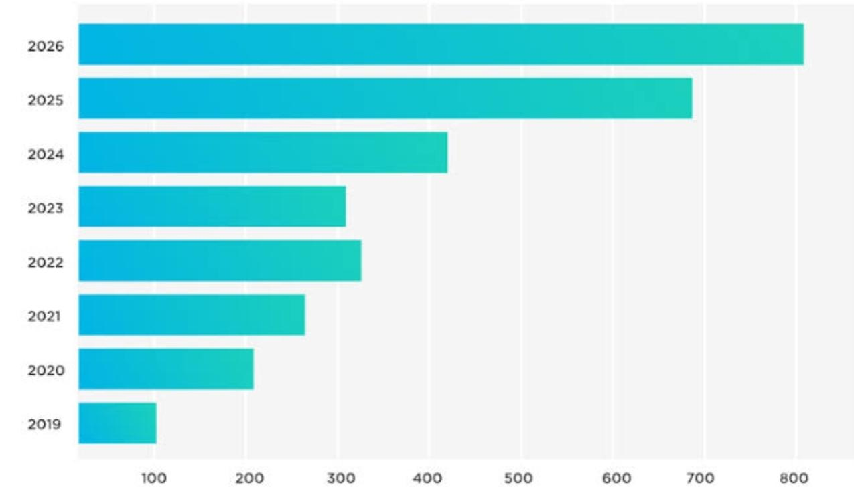

* **Line Charts**

Used to display trends over time.

Example: Tracking monthly revenue growth.

**Steps to Create:**

1. Select the data range.

2. Go to the Insert tab.

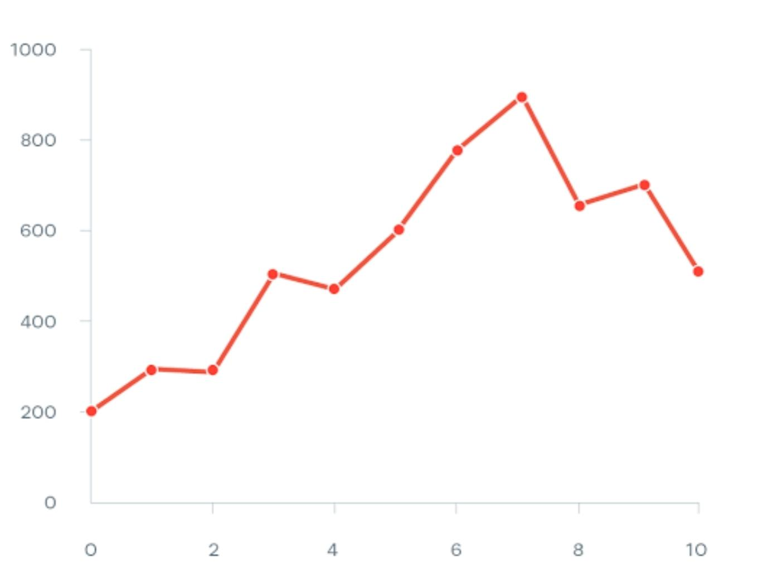3. Choose the Line Chart option.

* **Pie Charts**

Used to show proportions of a whole.

Example: Market share of different companies.

**Steps to Create:**

1. Select the data range (including labels).

2. Go to the Insert tab.

3. Choose the Pie Chart option.

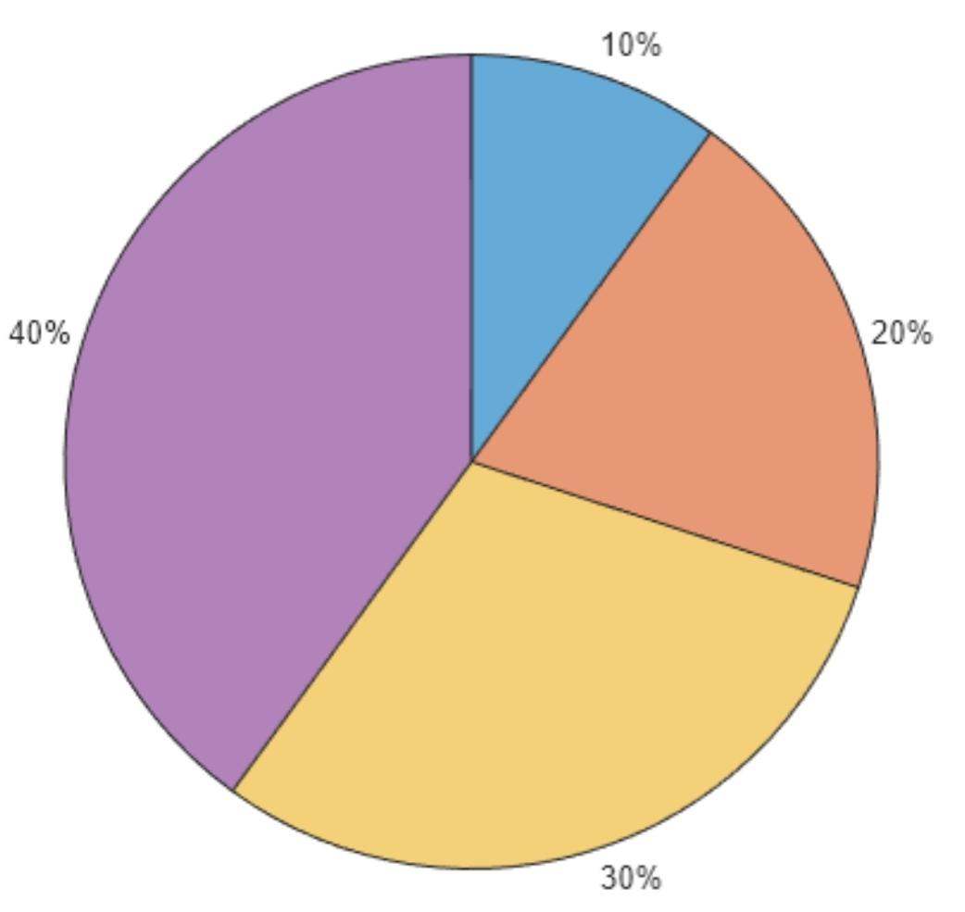**2. Conditional Formatting**

Conditional formatting allows you to highlight cells based on specific conditions, making patterns and trends easier to identify.

* **Examples of Conditional Formatting:**

Highlight cells greater than a certain value.

Apply colour scales to show high and low values.

Use data bars to visualize numbers within a range.

**Steps to Apply Conditional Formatting:**

1. Select the range of cells.

2. Go to the Home tab and click Conditional Formatting.

3. Choose a rule type (e.g., **"Highlight Cells Rules"** or **"Data Bars"**).

4. Define the condition and formatting style.

**Use Case:**

Highlight employees with sales exceeding $10,000 or mark overdue tasks.

**3. Creating Barcodes and QR Codes**

Barcodes and QR codes can be generated in Excel for inventory management, tracking, or marketing purposes.

**Barcodes:**

1. Install a barcode font (e.g., Code 39) on your computer.

2. Type the data to convert into a barcode.

3. Apply the barcode font to the cell.



**QR Codes:**

1. Use Excel's Power Query or an online tool to generate QR codes.

2. Alternatively, use a VBA script or external add-ins to create QR codes directly within Excel



**Use Case:**

Use barcodes for product identification and QR codes for links to product details or company websites.

**4. Working with Tables and Data Validation**

**Tables:**

Excel tables allow you to manage and analyse data efficiently. Tables include features like automatic formatting, filtering, and calculated columns.

**Steps to Create a Table:**

1. Select your data range.

2. Go to the Insert tab and click Table.

3. Ensure the **"My table has headers"** checkbox is selected.

**Data Validation:**

Data validation restricts user input to maintain data accuracy and consistency.

Examples of Validation Rules:

Restrict values to a specific range (e.g., 1-100).

Create dropdown lists for selecting predefined options.

**Steps to Apply Data Validation:**

1. Select the range of cells.

2. Go to the Data tab and click Data Validation.

3. Set the criteria (e.g., whole number, list).

**5. Frequency Function and Statistical Analysis**

**FREQUENCY Function:**

The FREQUENCY function calculates how often values occur within a range. It returns a distribution table of frequencies.

Syntax:

**=FREQUENCY(data_array, bins_array)**

Example:

If data_array contains test scores and bins_array defines score intervals, FREQUENCY will count scores in each interval.

**Statistical Analysis Functions:**

**1. AVERAGE:** Calculates the mean of a range.

Syntax: **=AVERAGE(A1:A10)**

**2. MEDIAN:** Finds the middle value in a dataset.

Syntax: **=MEDIAN(A1:A10)**

**3. MODE:** Identifies the most frequently occurring value.

Syntax: **=MODE(A1:A10)**

**4. STDEV:** Computes the standard deviation.

Syntax: **=STDEV(A1:A10)**

**5. CORREL:** Calculates the correlation coefficient between two datasets.

Syntax: **=CORREL(A1:A10, B1:B10)**

**Use Case:**

Statistical functions are crucial for analyzing sales trends, survey responses, or scientific data

**LAB 10 :**Advanced Tools and Final Project(Introduction to Pivot Tables, Using VLOOKUP and HLOOKUP, Introduction to Macros, Final Project: Analyse and Visualize Data Set Using Skills Learned Throughout the Course).

* **Advanced Tools in Excel and Final Project (Detailed Explanation)**

Excel provides advanced tools to analyse and visualize data effectively, allowing users to extract meaningful insights from complex datasets. This guide explains how to use Pivot Tables, VLOOKUP and HLOOKUP, Macros, and more, followed by a detailed structure for a final project to apply these skills.

**1. Introduction to Pivot Tables (Dynamic Data Analysis)**

Pivot Tables allow you to summarize, group, and analyse data interactively.

**Key Features of Pivot Tables:**

Grouping: Group data by date, category, or numerical ranges.

Summarizing: Perform calculations like sums, averages, and counts.

Filtering: Focus on specific data using slicers or filters.

**Steps to Create a Pivot Table:**

**1. Prepare the Dataset:**

Ensure your dataset has headers and is organized without blank rows or columns.

**2. Insert Pivot Table:**

Select your dataset.

Go to the Insert tab and click PivotTable.

Choose where to place the Pivot Table (new worksheet or existing one).

**3. Customize the Table:**

* Drag fields to the Rows, Columns, Values, and Filters areas.

Example:

* Rows: Product Names
* Columns: Regions
* Values: Sum of Sales

**4. Enhance the Pivot Table:**

Use the Design tab to style the table.

Apply slicers for interactive filtering.

**Use Case Example:**

Analyse sales data to find the top-performing products in each region.

**2. VLOOKUP and HLOOKUP (Data Lookup Functions)**

**VLOOKUP (Vertical Lookup):**

Finds specific data in a table based on a value in the first column.

**Syntax:**

**=VLOOKUP(lookup_value, table_array, col_index_num, [range_lookup])**

**Example:**

To find the price of **"Product A"** in a table:

**lookup_value = "Product A"**

table_array **= A2:C10 (the data range)**

**col_index_num** = 2 (price column)

**Formula: =VLOOKUP("Product A", A2:C10, 2, FALSE)**

**HLOOKUP (Horizontal Lookup):**

Searches for data in the first row of a table.

Syntax:

**=HLOOKUP(lookup_value, table_array, row_index_num, [range_lookup])**

Example:

To find January's sales in a table:

**lookup_value = "January"**

**table_array = A1:G5 (the data range)**

**row_index_num = 3 (sales row)**

Formula: **=HLOOKUP("January", A1:G5, 3, FALSE)**

**3. Introduction to Macros (Automating Tasks)**

Macros automate repetitive tasks by recording a sequence of actions in Excel. Macros are written in VBA (Visual Basic for Applications).

**Steps to Create a Macro:**

**1. Enable the Developer Tab:**

Go to File > Options > Customize Ribbon, and enable the Developer tab.

**2. Record a Macro:**

In the Developer tab, click Record Macro.

Perform the actions you want to automate (e.g., formatting a dataset).

Click Stop Recording.

**3. Run the Macro:**

Go to the Developer tab, click Macros, and select your macro to run it.

**Use Cases for Macros:**

Formatting datasets (e.g., applying borders, aligning text).

Generating repetitive reports.

Automating tasks like inserting charts or running calculations.

1. **Final Project:**

Analyse and Visualize a Dataset

This final project integrates the skills learned throughout the course to analyse, visualize, and present insights from a dataset.

**Step-by-Step Final Project Guide**

**Step 1: Choose a Dataset**

Example Dataset:

Sales Data, Employee Performance, Survey Responses.

Ensure the dataset includes columns like dates, categories, regions, and numerical values.

**Step 2: Clean the Data**

Use Data Validation to ensure input accuracy (e.g., restrict sales values to a specific range).

Remove duplicates using the Data tab.

Organize the data into a structured table.

**Step 3: Analyse the Data**

Use Pivot Tables to summarize data:

Create a Pivot Table to calculate total sales by region and month.

Group data by quarters or years for trend analysis.

**Apply VLOOKUP and HLOOKUP:**

Use VLOOKUP to retrieve product prices or details.

Use HLOOKUP to analyse trends across months.

**Perform Statistical Analysis:**

Use formulas like =AVERAGE(), =MEDIAN(), and =STDEV() for key metrics.

Calculate correlations with =CORREL().

**Step 4: Visualize the Data**

Charts and Graphs:

Create a bar chart for sales by product.

Use a line chart for monthly trends.

Include a pie chart to show market share by region.

**Conditional Formatting:**

Highlight top-performing products in green and underperformers in red.

**Step 5: Automate with Macros**

Record a macro to format the final report and insert charts automatically.

Automate repetitive tasks like data updates

**Step 6: Present Insights**

Create a Summary Report:

Use tables, charts, and Pivot Tables to present findings.

Include key metrics like total sales, average revenue, and top products.

**Example Final Project Report Structure**

**Title:**

**Sales Performance Analysis (or relevant project title).**

**Sections:**

**1. Introduction:**

**Objective of the analysis (e.g., identifying sales trends and top products).**

**2. Data Cleaning:**

**Mention steps taken to clean and prepare the data.**

**3. Analysis:**

**Insights from Pivot Tables and VLOOKUP results.**

**4. Visualization:**

**Include charts and graphs with captions.**

**5. Automation:**

**Explain the macros created for the project.**

**6. Conclusion and Recommendations:**

**Summarize key findings.**

**Provide actionable insights (e.g., focus marketing on top regions).**